D-311 Unit 6: Initial Attack / Incident Support

Unit Objectives:
- Describe the closest forces concept for incident support.
- Describe initial attack and extended attack incident resource support.
- Describe Initial Attack ordering procedures.
- Describe what are agreements and when they may be necessary.

Unit at a Glance:
Topics | Method | Duration
Basic Fire Terminology | Group Activity | 20 Minutes
The Fire Triangle | Presentation | 10 Minutes
Breaking the Fire Triangle | Presentation | 5 Minutes
Methods of Heat Transfer | Presentation | 10 Minutes
Suppression Terminology | Presentation | 5 Minutes
Knowledge Check | Group Activity | 5 Minutes
Total Unit Duration |  | 55 Minutes

Materials:
- IRPG
Guides and Key
The presentations and instructor guides include notes to aid facilitators in instruction.
Key
- Indicates an action for the instructor to take.
- Indicates topics and information for the facilitator to use as they see fit.

Example Slide 1
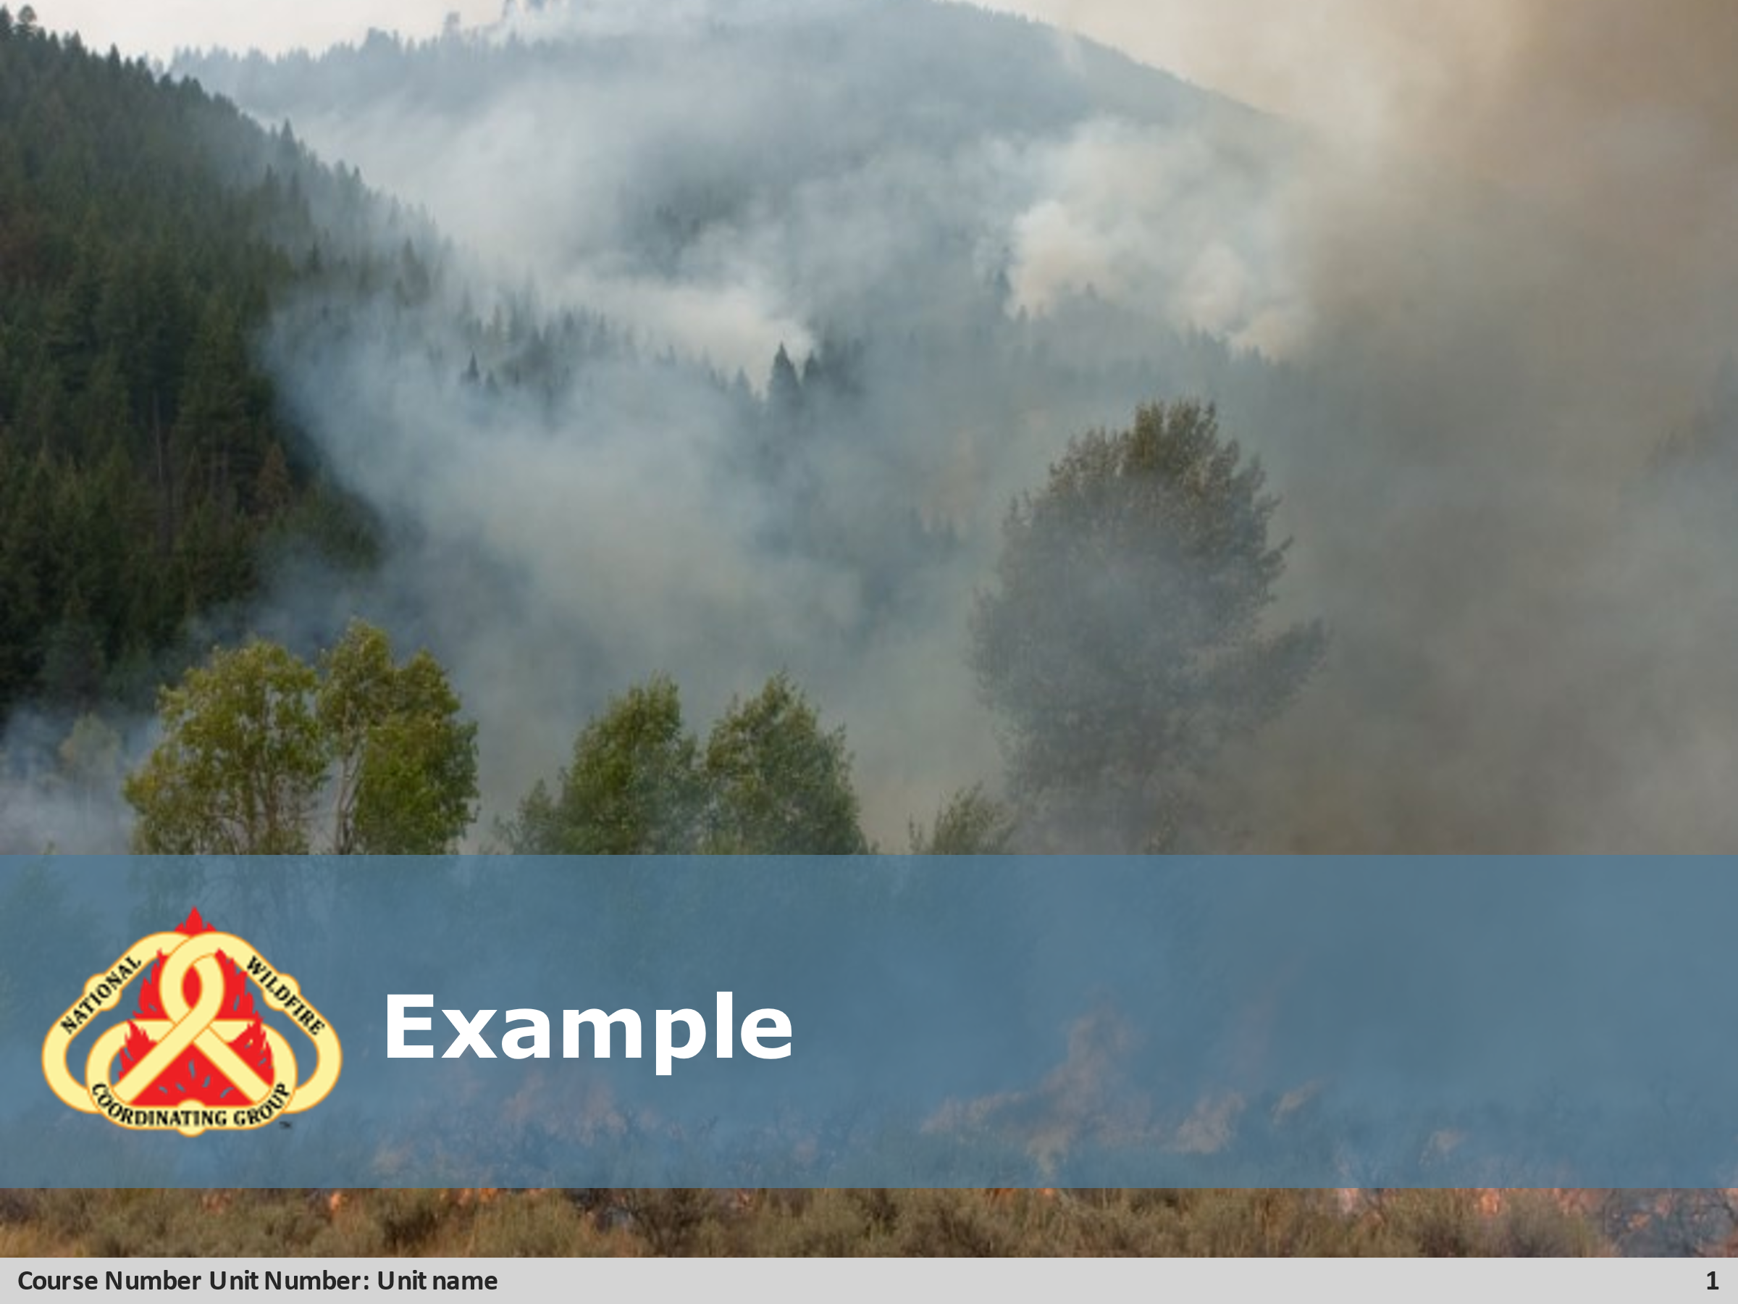
- Review unit objectives.
Exercise
- Advise participants that the next few slides will introduce common terms that describe parts of a fire.
Pre-Video Discussion
- In this scenario, firefighters have arrived on scene of a new fire. They are gathering and communicating their situational awareness of the current fire behavior.
- Play Video
Title Basic Fire Terminology
Summary State the summary
Time (02:20)
Audio
Post-Video Discussion
- This unit will discuss many of these terms in more detail.
Question: Identify this fire behavior.
Answer: Torching
Note to Instructor
The fuel types listed on this slide will be discussed in detail in Unit 2.

Lists
- Supplementing Initial Response
  - Follow local SOP and Mob guide:
    - Meals / Lodging
    - Caches items
    - Sheriffs for road control
    - Resource Advisor
    - Public affair
    - Fire investigator
- Extended Attack
  - Extended attack starts at the second operational shift.
  - IADP will have to perform support dispatcher type tasks to help with the increased workload.
    - Increased radio traffic
    - Intelligence information (spot weather, SIT-209)
    - Increased staffing needs and hours
    - Procurement requests and processing orders
  - Replacement of IA resources
    - Coordinate with agency fire staff for adequate unit coverage.
- Logistical Support
  - Incident Business
    - EERA
    - VIRP
    - NERV
    - AIMS (FS Only)
    - Purchasing
    - Land use agreements
    - Local Service Supply Plans
  - Local cache
    - Identify procedures for ordering
  - Facilities
    - Staging/ICP areas (fairgrounds, schools, mobilizations centers)
  - Transportation
    - Drivers

Slide 1
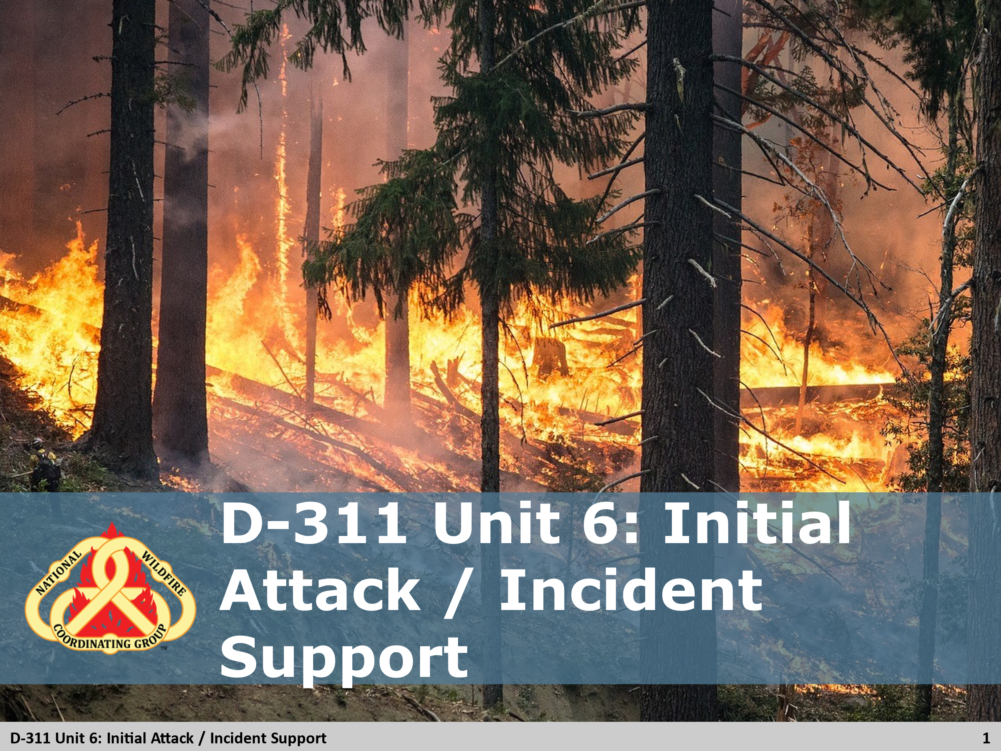

Slide 2
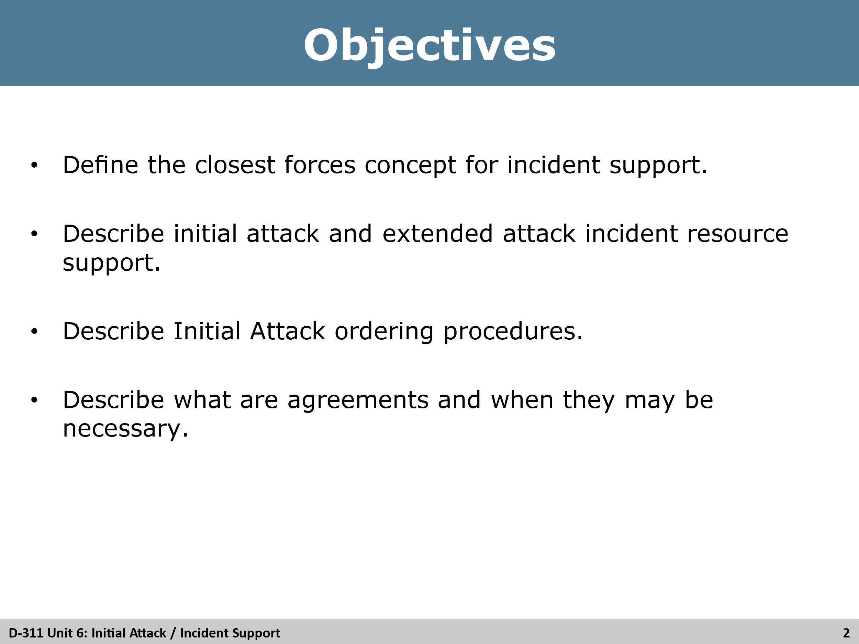

Slide 3
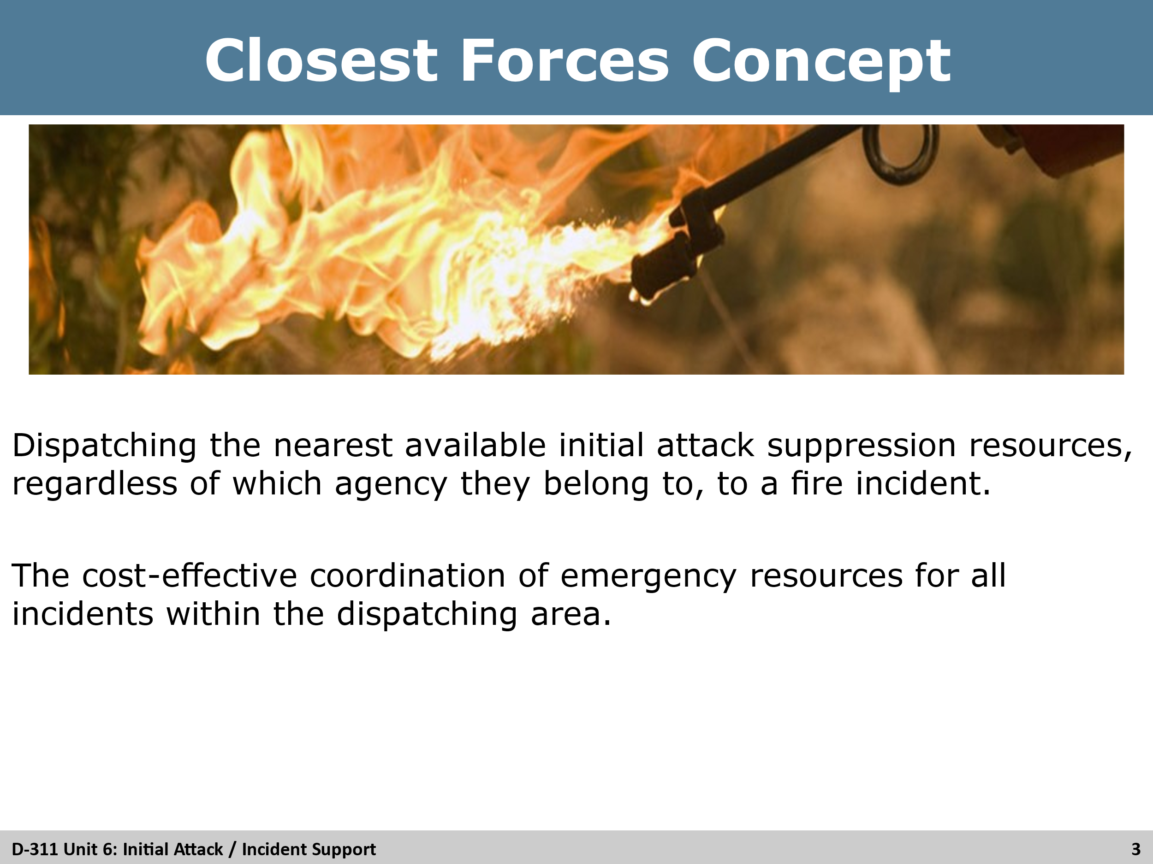

Slide 4
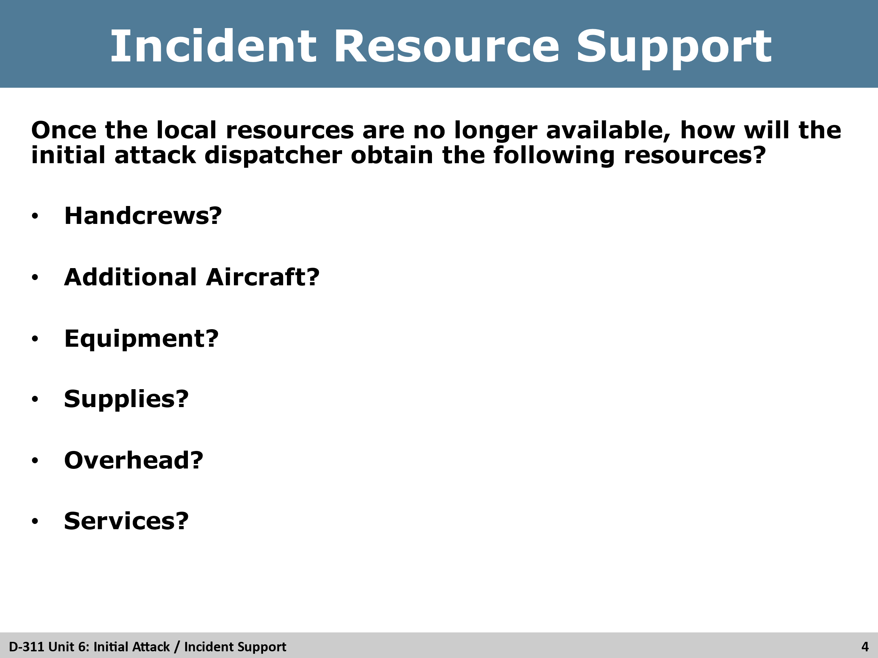

Slide 5
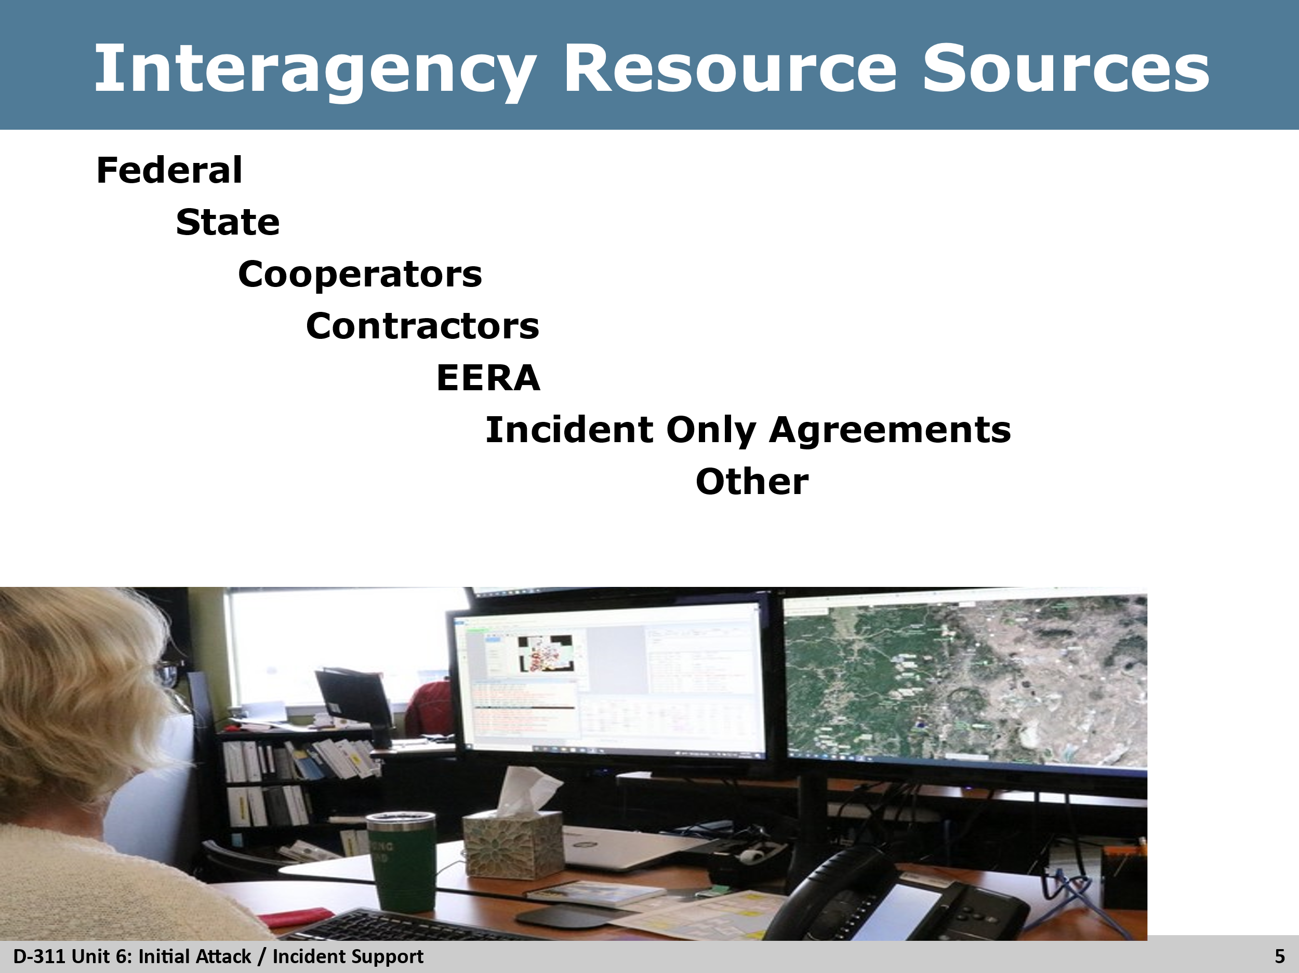

Slide 6
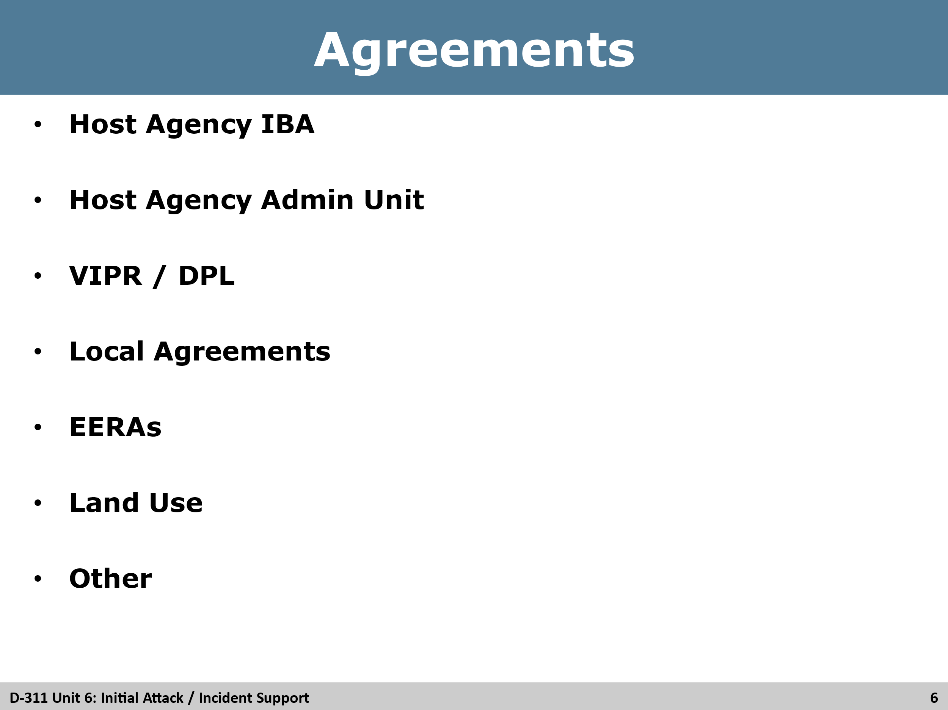

Slide 7
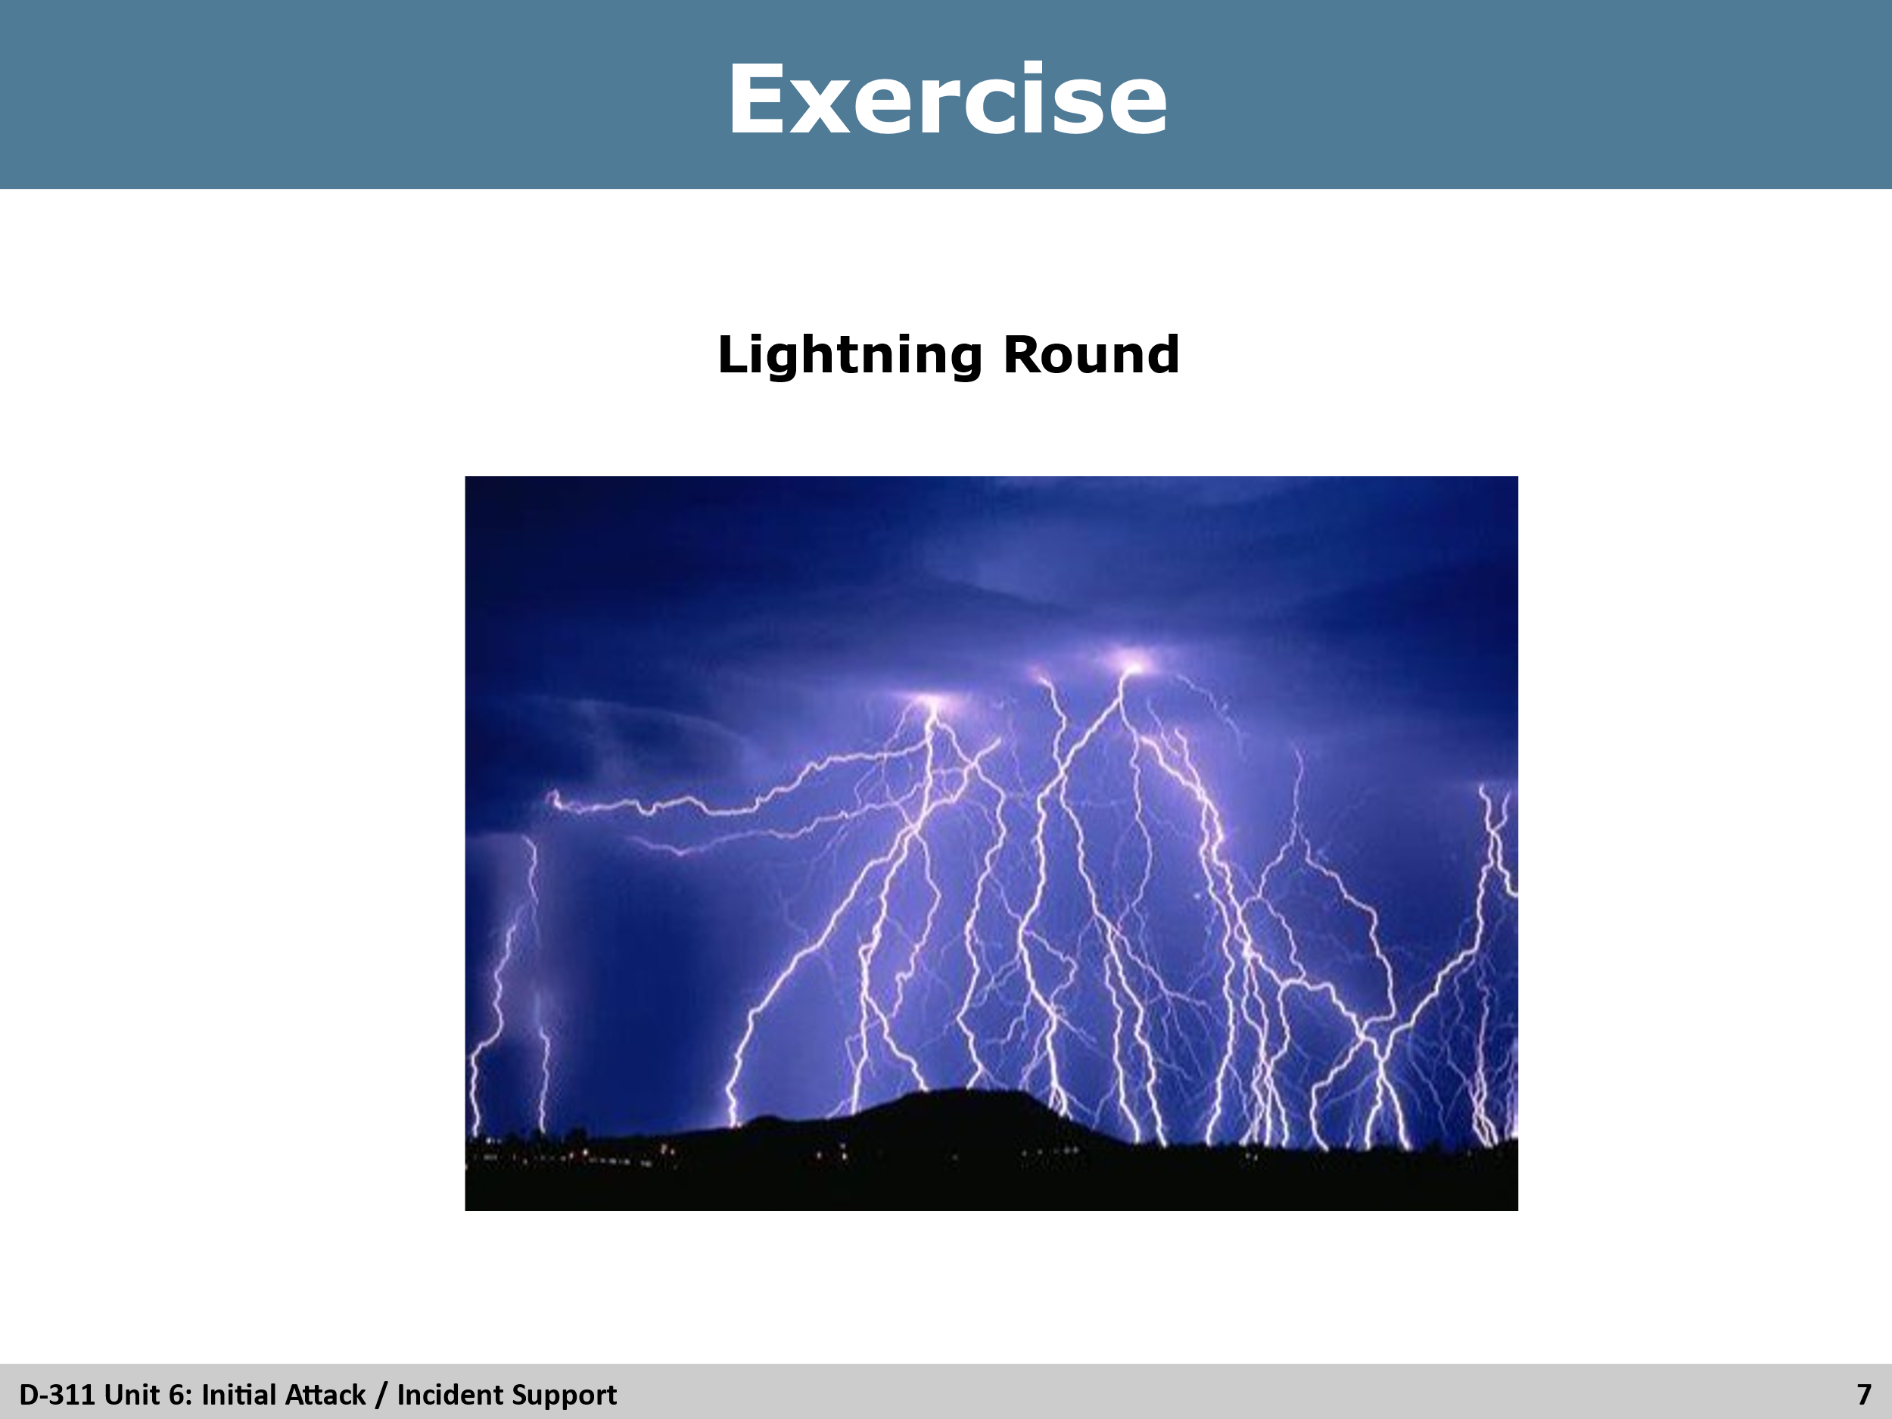
Each table will write a list of potential individuals they will communicate or pass information to as it refers incident support as an IADP, ex: IC, IBA, ORDM, etc. Give the class 15 minutes to compile their lists.
After lists have been made, there will be one cadre member that will act as overall judge, and one cadre member to keep score. The remaining cadre will help to ensure there are no repeated answers.
Winning team gets bragging rights.

Slide 8
